LAB 3: COMPONENT MODELLING & ARCHITECTURAL PATTERN SELECTION
Self-Service Coffee Kiosk System
Name | Pratham P Shetty
SRN | PES2UG24CS370
SECX

1.SCENARIO AND REQ;
The system is a self-service coffee kiosk in a busy café. Customers select Espresso, Americano, or Latte; choose Small or Large size; pay by credit card; and receive a printed receipt. The kiosk must support touch-screen interaction, communicate with receipt-printer hardware, and store menu and pricing information.
Key challenges: responsive touch interaction, reliable payment processing, protection of payment data, accurate pricing, dependable hardware communication, and quick order completion.

2.ARCHITECTURAL STYLE AND ANALYSIS

Architecture | Pros for this scenario | Cons | Assessment
Layered | Clear separation of UI, business logic and data; simple to understand and maintain. | Cross-layer calls add overhead; hardware/payment concerns can make layers cumbersome. | Good fit
Microservices | Independent deployment and scaling; fault isolation; technology flexibility. | Too much operational and network complexity for one kiosk; latency and distributed-data concerns. | Over-engineered
Client-Server | Centralized control and simple deployment; easy shared data management. | Creates a central bottleneck/single point of failure and is less suitable for kiosk-local hardware integration. | Acceptable, but less suitable

3.ARCHIOTECTURAL STRUCTURE AND ANALYSIS
Selected architecture: Layered Architecture. The kiosk is a compact application with a touch UI, central order logic, local menu/pricing data, payment integration, and a printer interface. A layered structure provides separation of concerns without the operational complexity of microservices.
1. Touchscreen UI Component: Captures customer selections, size, payment initiation, and order confirmation.
2. Order Manager Component: Coordinates the order lifecycle, validates selections, calculates totals, and triggers payment/receipt actions.
3. Payment Service Component: Processes credit-card payment requests and returns success/failure status.
4. Menu & Pricing Repository Component: Stores and retrieves coffee types, sizes, and current prices.
5. Receipt Printer Interface Component: Formats receipt data and communicates with the physical receipt printer

4.Component Diagram Creation

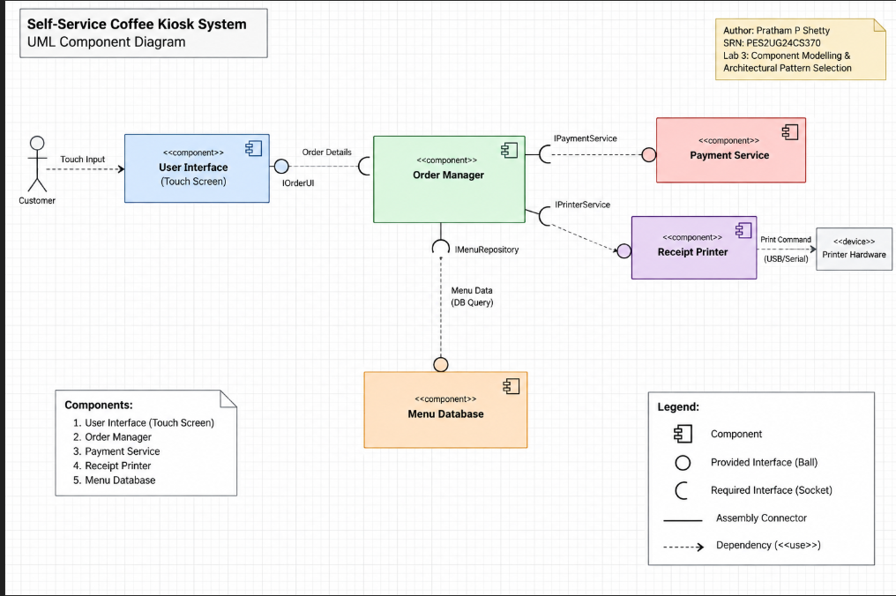

5.JUSTIFICATION
Architecture Selection: We chose Layered Architecture for the Self-Service Coffee Kiosk System.
Architectural Choice: Layered Architecture separates presentation, order/business logic, data access, and hardware/service integration.
Reason 1: The kiosk has a small, well-defined workflow. Separating the touchscreen UI from Order Manager logic makes the system easier to test, maintain, and modify without changing the customer-facing interface.
Reason 2: The architecture supports the kiosk's local menu/pricing repository and hardware printer through clear interfaces. Payment processing can also be isolated behind a service interface, reducing coupling.
Security Advantage: Payment functionality is isolated in the Payment Service component. The Order Manager sends only the information required for payment processing and does not need to expose payment implementation details to the UI.
Performance Benefit: Local menu/pricing access avoids unnecessary remote service calls for routine selections. Direct component communication and local hardware integration reduce latency and help the kiosk remain responsive during ordering.

6.INTERFACE SUMMARY
Interface | Provider | Consumer | Purpose
IOrderManagement | Order Manager | Touchscreen UI | Submit selections and receive order status
IPaymentProcessing | Payment Service | Order Manager | Process credit-card payment and return status
IMenuPricing | Menu & Pricing Repository | Order Manager | Retrieve menu items and prices
IReceiptPrinting | Receipt Printer Interface | Order Manager | Print completed order receipt

